Open Nox (Nox Screen Relation is Irrelevant) and click on the Record Button

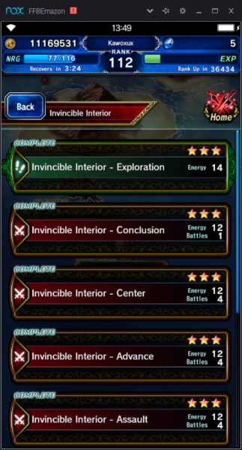

The Following Screen will pop-up:

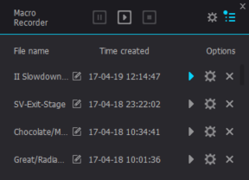

Press play and you’ll see it says recording in the top left:

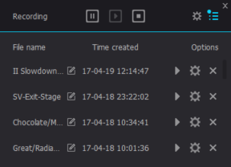

Click anywhere on nox screen

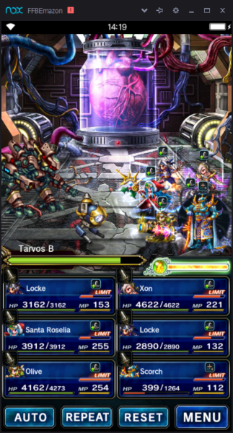

Click Stop:

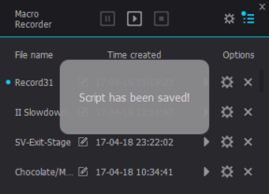

Now browse to:

C:\Users\\*\*\*YourUsername\*\*\*\AppData\Local\Nox\record

(replacing \*\*\*YourUsername\*\*\* with your actual PC Username)

Sort by Date Created - you may have to right click columns to choose this field:

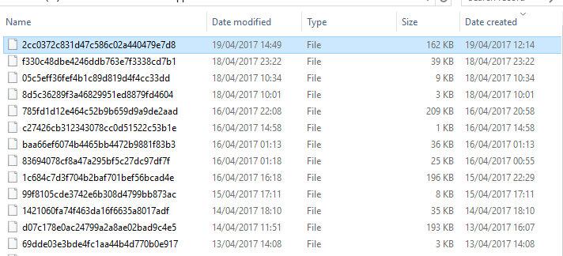

Right click on the top line and choose "Edit with Notepad" - Delete all current lines (there should be 5 if doing this in Nox)

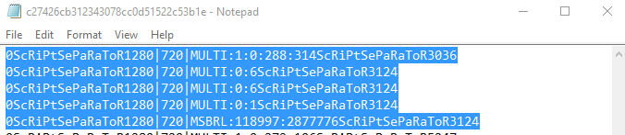

In your browser click the link of whatever script you want @ <https://macroteam.github.io/FFBE-Macros/>

Then CTRL+A to select all, then CTRL+C to copy

Paste the data into the notepad file and then save and close it.

You'll notice that the file size in windows explorere will increase when you hit save from 1kb to a much larger amount(See previous screenshot)



Then in Nox it's worth renaming your script using the little icon next to Record1 (it looks like a box with a pencil in it).

Ensure you have your party Setup, then navigate to the relevant start location and hit Go!